PUTNAM COUNTY JOB AND FAMILY SERVICES
INFORMATION GUIDE
Information on Services, Benefits, Programs and Personnel

Putnam County Job and Family Services
575 Ottawa-Glandorf Road, Suite 1
Ottawa, Ohio 45875

Telephone: 567.376.3777
CSEA: 567.376.3780
Toll Free: 800.523.5799

JFS Main Fax: 567.376.3770
CSEA Fax: 567.376.3786
Social Services Fax: 419.538.6932
Income Maintenance Fax: 567.376.3740
Workforce Development Fax: 567.376.3760

Hours of Operation:
Monday through Thursday
7:00 AM – 4:30 PM
Fridays
7:00 AM – 12:00 PM

INFORMATION GUIDE
TABLE OF CONTENTS

Agency Vision, Mission and Value Statement Page 2

Table of Organization Page 3

Agency Operation Page 4

Public Assistance Pages 5-6

Social Services Pages 7-8

Workforce Development Pages 9-10

Child Support Enforcement Page 11

Business Office Page 12

Customer Rights and Responsibilities Page 13

Client Responsibilities Page 14

Our Vision

Empowering People. Supporting Families. Strengthening Community.

Our Mission

With compassion and dignity, Putnam County Job and Family Services strives to build strong relationships, promote well-being, provide accessible services, embrace new ideas, and focus on what matters most: helping people live better lives and strengthening our community.

Our Values

Customer Service, every child, family and individual will be afforded prompt courteous service in all areas of our agency.

Quality, knowledgeable trained staff will provide competent services that our customer expects and deserves.

Integrity, our employees will serve the county and its citizens honorably and with high ethical standards.

Communication, we will communicate with our customers in a responsive, productive and courteous way.

-2-

TABLE OF ORGANIZATION
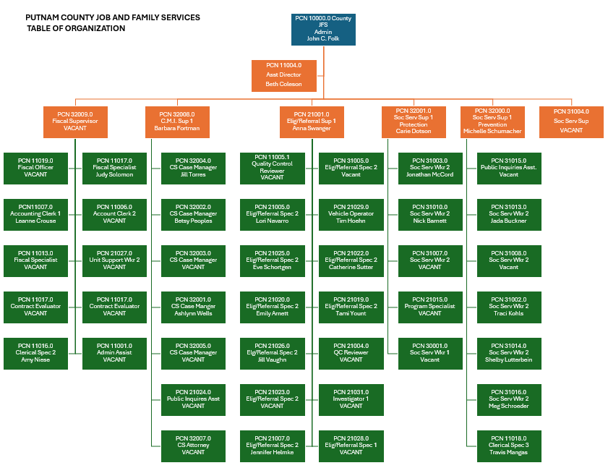

John C. Folk, Director
Beth A. Coleson, Assistant Director

-4-
PUBLIC ASSISTANCE
Anna Swanger, Supervisor

Unit Staff
Catherine Sutter Jennifer Helmke Jill Vaughan
Tami Yount Emily Arnett Tim Hoehn

RESPONSIBLE FOR:
PREVENTION, RETENTION AND CONTINGENCY (PRC) program is designed to assist low income families with necessary resources to:

Divert families from having to apply for OWF cash assistance when a crisis situation arises.
Provide for contingent needs by helping families with nonrecurring urgent problems that could result in families needing long-term public assistance and aid with a state declared disaster.

OHIO WORKS FIRST (OWF) is part of Ohio’s Temporary Assistance to Needy Families (TANF) program and was established to provide time-limited cash assistance to eligible families. The OWF program provides cash benefits to eligible needy families for up to 36 months if they fulfill all of the requirements in their Self-Sufficiency Plan and Contract.

The emphasis of OWF is self-sufficiency, personal responsibility and employment. Eligibility determinations are based on the provisions contained in the Ohio Revised Code and the Ohio Administrative Code.

SNAP PROGRAM helps people with low income obtain nutritious food. SNAP is used to purchase specific staples and grocery items at participating grocery stores. Eligibility is based on federal guidelines including income, resources and household sizes. SNAP is issued by the United States Department of Agriculture and eligibility is determined by the county job and family services.

MEDICAID is a state and federally funded health care coverage plan for low-income and medically vulnerable people of all ages. Medicaid provides health coverage to a number of different groups of people who meet financial requirements. There are two major groups, covered Families and Children, and people who are Aged, Blind or Disabled.

-5-
PUBLIC ASSISTANCE (CONTINUED)

MAGI (Modified Adjusted Gross Income)
MAGI provides coverage for individuals, children, and families who have income at or below 133% of the Federal Poverty Guideline. Children only can be covered from birth through age 18 in families with income at or below 206% of the Federal Poverty Guideline. Children in families with income between 156% and 206% of the Federal Poverty Guideline must be uninsured in order to be eligible. A pregnant woman’s family income must be at or below 200% of the Federal Poverty Guideline to qualify.

Coverage for Aged, Blind, or Disabled
Medicaid provides coverage for adults 65 and older, individuals who are legally blind, and individuals of any age who have been determined disabled by the Social Security Administration. This type of coverage is also offered to Nursing Home residents and individuals who are in need of in-home care. Eligibility is based on monthly income and asset limits.

Medicaid coverage includes:
The Basic Health Plan
The Long-Term Care Health Plan
Medicaid Premium Assistance
The Hospital Care Assurance Program
The Disability Assistance Program

-6-
Social Services
Carie Dotson & Michelle Schumacher, Supervisors

Carie Dotson, Protection Supervisor  Jonathan McCord  Nick Barnett  Traci Kohls | Michelle Schumacher, Prevention Supervisor  Meg Schroeder  Shelby Lutterbein  Jada Buckner  Travis Mangas

Protection Unit

Intake/Investigation/Assessment – The agency receives, investigates and assesses reports alleging that a child is at risk or has been abused or neglected. Anyone who knows or suspects that a child under 18 years of age, or a physically or mentally handicapped child under 21 years of age, has suffered or faces a threat of suffering any physical or mental wound, injury, disability, or other condition of a nature that reasonably indicates abuse or neglect of the child, may make a referral or cause a referral to be made of that knowledge or suspicion to PCJFS or to a municipal or county peace officer by calling the Agency, 567-376-3777 during normal business hours, or by calling the Putnam County Sheriff’s Office, 419-523-3208, after normal Agency business hours or on weekends.

On-going Child Protective Services – The agency provides services to families to prevent or reduce the level of risk to children. The agency strives to maintain children in their own homes.

Foster Care – The agency supervises and monitors the placement of abused/neglected children, with oftentimes a goal of reunification. A certified assessor licenses Putnam County foster homes. A person who is interested in becoming a licensed foster parent may contact the Agency at 567-376-3777.

Community Education – Agency presents information to groups on a variety of topics, in a formal or informal setting.

-7-
SOCIAL SERVICES (CONTINUED)

Prevention Unit

Child Care – Child care assistance is available in order for families to become or remain self-sufficient.

Child Safe Program – A program presented to first, third and fifth grade students regarding good/bad/secret touches. Children are empowered to say “no” to bad touches and are given an opportunity to discuss concerns with a trained professional.

Prevention, Retention, and Contingency (PRC) – program is designed to assist low income families with necessary resources to: Provide for contingent needs by helping families with nonrecurring urgent problems that could result in families needing long-term public assistance, example: housing and utilities.

Social Services Request – Caseworkers are available to provide information, referral, and case management services.

-8-
Workforce Development
Anna Swanger, Supervisor

Unit Staff
Lori Navarro Eve Schortgen

The Workforce Development unit offers job seekers, workers, and employers a full range of employment-related services.

Workforce Innovation and Opportunity Act (WIOA) provides the framework for a workforce and employment system to meet the needs of employers, job-seekers and those who want to advance their careers. WIOA is designed to increase employment, job retention, earnings of participants, and occupational skill attainment by participants. WIOA provides employment and training services that targeted adults, dislocated workers and youth.

Putnam County WIOA provides:
Career Services – Available to any and all customers. Resume preparation and cover letter writing also job application and interviewing assistance.

Training Services – Provided to customers who meet the eligibility criteria. Tuition and book fee assistance.

OhioMeansJobs

Access to the internet for computer-based job matching, telephones, and resource materials for job searching.

Job postings

www.jobseeker.ohiomeansjobs.monster.com – Free public employment services to employers and job-seekers. Job matching and labor market information.

Labor Market information www.lmi.state.oh.us

Unemployment Compensation Benefits information and availability to file for claims online or over the telephone www.unemployment.ohio.gov or 1-877-644-6562.

-9-
Workforce Development (Continued)

OhioMeansJobs Center Partners

ODJFS Customer Service Representative
ODJFS Veteran’s Representative
Opportunities for Ohioans with Disabilities (OOD)

Other programs and services available through Workforce Development:

Food Stamp Employment and Training (FSET) offers a wide array of Workforce Development services to food stamp recipients who are not participating in OWF. These services are:
Employment placement assistance and work experience
Basic education, including preparation for the High School Equivalency Diploma (HSED)
Post-secondary education, job readiness training and job search assistance

Ohio Works First (OWF) Activities requires all single parents who are receiving cash assistance to participate in work activity for at least 30 hours per week. Two-parent households are required to participate at least 35 hours per week and 55 hours if they are receiving federally funded child care. For adults who cannot participate in traditional work activities and requirements, alternative or developmental activities are assigned based on an individual’s circumstances.

Prevention, Retention and Contingency (PRC) program is designed to assist low income families with necessary resources to:

Assist employed or underemployed families retain employment.

-10-
Child Support Enforcement
Barbara Fortman, Supervisor

Unit Staff
Jill Torres Betsy Peoples
Ashlynn Wells

Responsible for:

- Collection and disbursement of ordered child and spousal support payments and maintaining an accurate record of those payments.
- Providing services to locate an absent parent responsible for support.
- Administratively modify an existing support order, provided the request for a review meets specific review criteria.
- Withholding support through an income withholding notice to an Obligor’s employer, Unemployment or Workers’ Compensation benefits, or funds on deposit in a financial institution.
- Obtaining an order for medical insurance coverage.
- Using the federal and state income tax offset programs to collect past due support. Some submission restrictions apply.
- Reporting the amount of past due support owed by an Obligor to a credit reporting agency.
- Establishing paternity by acknowledgement of the parent or by genetic testing and order support for a child born out of wedlock.
- Referring child support cases to court for enforcement and contempt actions.
- Suspending professional, driving and recreational licenses of Obligors in default.
- Initiating criminal non-support for prosecution for flagrant non-payers.
- Establishing an arrearage payment on past due child support through an administrative default action. Initiating interstate action for enforcement of orders when the Obligor resides.

-11-
Business Office
John C. Folk, Director
Beth A. Coleson, Assistant Director

Unit Staff
Amy Niese Leanne Crouse
Judy Solomon

Responsible for all the agency fiscal and business functions including front reception.

-12-
CUSTOMER RIGHTS & RESPONSIBILITIES

EQUAL OPPORTUNITY IN JOB & FAMILY SERVICES
Individuals eligible for, receiving services from or benefiting from programs funded by or through ODJFS are protected by various laws, regulations, rules and policies against unlawful discrimination on the basis of race, color, religion, disability, age, gender, sexual orientation and national origin.

Non-Discrimination Policy
Putnam County Job and Family Services will not discriminate against any person because of race, religion, ethnicity, language, national origin, sex, age, handicap, or have other identified impairments that would severely limit communication. Interpretive services will be arranged in a timely manner and will be made available per request of all appointments, interventions with the family, and the individuals. The agency will provide these services at no cost to the client.

The Civil Rights program provides technical assistance on civil rights issues and ensures that all the functions, services and programs administered by ODJFS are carried out in compliance with the state and federal civil rights laws. This includes but is not limited to ensuring compliance with Title VI and Title VII of the Civil Rights Act, the American with Disabilities Act (ADA), Section 504 of the Rehabilitation Act, the Age Discrimination in Employment Act (ADEA), the Multi-Ethnic Placement Act (MEPA), and the Civil Rights Laws of Ohio. The program is also responsible for monitoring accessibility and overseeing accommodation requests for persons with disabilities and overseeing the bureau’s involvement in the Minority Business Enterprise program.

Limited English Proficiency (LEP) ensures that persons who have a limited English proficiency are protected against discrimination based on national origin. Accommodations may include providing qualified interpreters, language cards/lines, oral translation and/or written translation of documents.

STATE HEARINGS are available for customers who do not agree with decisions made about their benefits. A state hearing is a meeting with the customer, someone from the county department of job and family services and a hearing officer from the Ohio Department of Job and Family Services. Customers can explain why they disagree with decisions made about their benefits. Friends, witnesses and attorneys can help customers present their cases. The hearing officer listens to both sides and gives a decision after reviewing the rules. For more information on state hearings, ask for the publication Your Rights – JDS #08000.

GRIEVANCE REVIEW POLICY functions as a means through which Putnam County Job and Family Services (“PCJFS” or “Agency”) may receive, review, and resolve complaints from parents, custodians, legal guardians, foster caregivers, foster caregiver applicants, kinship care providers, adoptive parents, adoptive applicants, approved adoptive families, applicants or providers of approved adult-supervised living arrangements, or children concerning the provision of services, and appeals by alleged perpetrators who disagree with the disposition/resolution of a report of child abuse or neglect (NOTE: Cases involving any court action relating to the child abuse and neglect report are exempt from this requirement). Written copies of the Agency’s “Grievance Review Policy” shall be provided with a copy of the “Grievance Review Policy” at the time of the official notification of the case disposition. The Grievance Review Policy also allows for review/resolution of complaints of the Multiethnic Placement Act (MEPA).

-13-
CLIENT RESPONSIBILITIES:

As a recipient of services from Putnam County Job and Family Services, you have the responsibility to: Provide a safer, clean, and loving home for your child(ren) and provide for your child(ren)’s basic minimum needs.

OTHER RESPONSIBILITIES:
Give complete, accurate, truthful, and timely information.

Report changes in your situation and/or address to your caseworker/social worker in a timely manner.

Be on time for scheduled appointments with agency staff.

Participate in developing, reviewing, and evaluating, case plans, safety plans, aftercare and self sufficiency plans for you and your family.

Meet with your caseworker and other staff to review progress.

Understand and follow through with service plans and the requirements for each service that you are seeking.

Do Not carry concealed weapons or dangerous substances onto these premises.

Indian Child Welfare Act
The Indian Child Welfare Act (ICWA) is a federal law which regulates how child welfare agencies provide services to Native American children & families. If your child is a member of a tribe, or eligible for membership in a tribe, your family has a right to be provided services in accordance with the ICWA. Please inform your caseworker about your family’s Native American heritage and your caseworker will explain how the ICWA may apply to your family. Criteria for tribal membership differ from one tribe to another. In order to determine a particular tribe’s criteria, it is necessary to contact the tribe directly.

-14-

